AI-Powered Imaging Technology

**Daun Kim, Sravani Patlolla, Reshmi Deb**  
Department of Biomedical Informatics  
University of Nebraska at Omaha  
Omaha, U.S.A  
Emails: [daunkim@unomaha.edu](mailto:daunkim@unomaha.edu),

[spatlolla@unomaha.edu](mailto:spatlolla@unomaha.edu),

[rdeb@unomaha.edu](mailto:rdeb@unomaha.edu)

*Abstract*— Dental caries remains a significant concern across all age groups, particularly in young children. Although X-ray imaging is widely used for caries detection, it is often time-consuming, uncomfortable for patients, and can be costly. The current study aimed to develop a machine learning-based approach to detect dental caries using images captured with mobile devices and high-resolution cameras, offering a more accessible and patient-friendly alternative.

YOLOv8 (You Only Look Once, version 8) and YOLOv11 (You Only Look Once, version 11) object detection models were selected for this purpose due to their real-time processing capabilities. A dataset of over 150 dental images was collected from publicly available sources and categorized based on image resolution and tooth positioning within the oral cavity was considered, including images of both front (anterior) and back (posterior) teeth, captured from different angles such as occlusal (top view), buccal (cheek side), and lingual (tongue side) surfaces. Images were then split into training, validation, and testing sets using stratified random sampling. Data labeling was conducted using the LabelImg tool, and various data augmentation techniques were applied to improve the model's reliability and performance.

The models were trained on datasets with and without augmentation. Performance evaluation was carried out using standard diagnostic metrics such as true positive, true negative, false positive, false negative, and mean average precision (mAP). While neither YOLOv8 nor YOLOv11 achieved complete accuracy across all lesion types, both demonstrated strong potential in identifying visible carious regions. This approach shows promise in improving diagnostic accuracy, reducing reliance on traditional X-ray methods, and enhancing patient comfort through non-invasive and cost-effective screening tools.

Keywords— Dental caries, yolo, object detection, radiographs, data augmentation

# Introduction

Dental caries, also known as tooth decay or cavities, are a chronic, progressive disease resulting from the bacterial demineralization and destruction of the hard tissues of the tooth, including enamel, dentin, and cementum. Although it is not life-threatening, dental caries are among the most prevalent oral health conditions worldwide, affecting individuals across all age groups. The disease often progresses silently and remains asymptomatic until it reaches an advanced stage, causing pain, infection, and eventually leading to tooth loss if left untreated. This not only affects the physical health of patients but can also lead to significant financial burdens due to complex treatments and repeated dental visits.

Timely detection and accurate diagnosis of caries are critical for effective intervention and prevention of further complications. Traditional diagnostic methods, including visual-tactile examinations and interpretation of dental radiographs (such as bitewing and periapical X-rays), are the standard approaches used in clinical settings. However, these methods rely heavily on the clinician's experience and judgment, which introduces a degree of subjectivity. Variability in interpretation may result in missed diagnoses, overdiagnosis, or inconsistent treatment plans. Moreover, these conventional techniques can be time-consuming and are not always feasible in community or low-resource settings.

To address these limitations, there is a growing need for innovative, efficient, and more objective diagnostic approaches. In recent years, artificial intelligence (AI), particularly deep learning (DL), has emerged as a powerful tool in medical imaging and diagnostics. Within the field of dentistry, convolutional neural networks (CNNs) have been extensively studied and applied for detecting dental caries on X-rays and images of the oral cavity. These models have demonstrated strong capabilities in recognizing dental anatomy, identifying carious lesions, and differentiating between healthy and decayed tooth structures. Their ability to learn from large datasets and improve over time offers a promising alternative to traditional diagnostic workflows.

One of the most effective deep learning models for object detection tasks is the YOLO (You Only Look Once) algorithm. YOLO is a real-time object detection system that reframes object detection as a single regression problem, directly predicting bounding boxes and class probabilities from full images in one evaluation. Unlike other models that perform region identification followed by classification (e.g., R-CNNs), YOLO is extremely fast and efficient, making it well-suited for clinical applications that require rapid and accurate assessments. Its architecture allows for detecting multiple objects in images with a high degree of accuracy, and recent versions such as YOLOv5, YOLOv8, YOLO NAS, and YOLOv11 have further improved in terms of speed, precision, and usability.

The integration of YOLO models into dental diagnostics opens the door for automated caries detection using not just X-rays but also intraoral photographs captured via high-resolution cameras or mobile devices. This advancement can enable timely diagnosis even outside traditional dental settings, making oral healthcare more accessible and standardized.

This study explores the development and validation of a YOLO-based deep learning system for automated detection of dental caries from clinical images. The goal is to evaluate its performance, analyze its diagnostic indicators, and assess its potential to support and enhance clinical decision-making in dentistry.

While AI-based systems have shown promise in dental diagnostics, one major challenge remains—image standardization. Factors like lighting differences, image quality, and user handling make it difficult to maintain consistent results. Because of these limitations, it’s difficult to use automated tools for cavity detection, and there hasn’t been much research on how accurate AI can be when using images taken with regular cameras under such varied conditions.

This study aims to develop and validate a simple, low-cost system that uses advanced AI techniques, like model combination and transfer learning, to detect dental cavities from non-standard dental images, while still ensuring the results are accurate and clinically useful.

# Literature review

Artificial Intelligence (AI) has revolutionized dental caries diagnosis by improving accuracy and efficiency through machine learning (ML) and deep learning (DL) techniques. Traditional methods like visual-tactile examination and radiographic imaging often struggle with early detection and subjectivity, leading to diagnostic inconsistencies (Selwitz et al., 2007). AI-driven approaches, particularly Convolutional Neural Networks (CNNs) and Support Vector Machines (SVMs), have shown superior accuracy in analyzing dental images, identifying caries with over 90% precision (Yamashita et al., 2018). AI-powered tools such as AssistDent and YOLOv3-based object detection models have further improved real-time detection, reduced false positives and increased diagnostic efficiency (Ding et al., 2021). However, challenges such as data privacy concerns, model bias, and clinician acceptance remain critical obstacles to widespread adoption (Rischke et al., 2022). Future advancements in federated learning, tele-dentistry integration, and explainable AI (XAI) are expected to refine AI-driven diagnostics, making them more accessible and reliable for dental professionals.

Recent advancements in AI-driven dental imaging have demonstrated promising results in improving diagnostic accuracy and efficiency. AbuSalim et al. (2024) introduced a multi-granularity approach using YOLO-based object detection models for effective tooth detection and classification. Their findings suggest that AI-powered imaging can significantly enhance diagnostic precision, reducing errors associated with manual inspections. Furthermore, Ramírez-Pedraza et al. (2025) explored deep learning applications in oral hygiene, specifically focusing on automated dental plaque detection using the YOLO framework. Their study highlights the potential of AI models in improving preventive dental care by offering real-time detection and quantification of dental plaque using the O’Leary Index. These advancements indicate a growing trend toward AI integration in dentistry, paving the way for innovative solutions that minimize patient discomfort while optimizing clinical workflows.

AbuSalim et al. (2024) explore the application of YOLO-based object detection models for dental image analysis, specifically focusing on tooth detection and classification. The study addresses the limitations of traditional dental imaging techniques and evaluates the effectiveness of AI-driven solutions. The researchers investigate whether YOLO-based object detection can enhance tooth classification accuracy compared to conventional methods. Their methodology involves training a YOLOv5 model on clinically sourced dental images, preprocessing the data, and evaluating model performance using standard accuracy metrics such as mean Average Precision (mAP). The findings indicate that AI-based object detection significantly improves diagnostic accuracy, reducing errors commonly associated with manual inspections. The study demonstrates that YOLO models can efficiently identify multiple teeth with high precision, highlighting the potential for real-time AI-assisted dental analysis. However, the research also notes certain limitations, such as the relatively small dataset size, which may affect generalizability, and the dependency on high-quality image preprocessing for optimal performance. The study contributes to the field by demonstrating the feasibility of AI-powered dental diagnostics and emphasizing the importance of dataset quality in model training. This research is highly relevant to the current project, as it provides a strong foundation for leveraging YOLO-based models in dental imaging. Building on these findings, our study will extend this work by utilizing YOLOv8, incorporating a more diverse dataset, and refining detection accuracy and efficiency for practical clinical applications.

The study by Salahin et al. (2023) focuses on using smartphone images to detect cavities in teeth. It uses the YOLOv5 model for object detection because it is fast and accurate. The model creates feature maps in three different sizes to detect small, medium, and large objects in the images. To see how well the model performs, the study measures accuracy using mean average precision (mAP) by checking true positive and false positive results. The results show that YOLOv5 works well for detecting medium and large cavities but is slightly less accurate with small ones. This research shows that smartphone images can be a simple and affordable way to screen for cavities.

According to Ali and Zhang (2024) gave a detailed overview of how the YOLO model has developed over time and how it’s used in different areas. They explained that YOLO is popular because it’s fast and accurate, which makes it great for tasks that need quick results, like real-time detection. The review also showed how YOLO has been used in many fields, including healthcare, traffic systems, and security. They compared different versions of YOLO with other models and found that YOLO performs well in terms of both speed and accuracy.

# Methodology

## Dataset preparation and preprocessing

***1) Data Collection:*** To collect data, we started by gathering dental images from available sources. Some of these images come from public datasets, like those on Kaggle. All the data used is de-identified, containing no patient information and fully compliant with privacy and HIPAA regulations. The dataset should include both healthy teeth images (no cavities) and cavity images (with cavities). Having a large and well-balanced dataset is important because it helps the model learn more effectively.

***2) Data Augmentation:*** In this project, data augmentation techniques are used to increase the size of our dataset by applying different transformations to the images. These transformations include flipping, cropping, resizing and rotation. By applying these techniques, we created a more varied set of training images, to help the model learn discriminative features for detecting dental caries under varying conditions. This makes the model better at generalizing, so it can work well on new and unseen images.

***3) Data Processing:*** We used the NumPy and Pandas libraries to manage and simplify the data. NumPy helped with numerical tasks like handling image pixels and performing operations on them. Pandas are used to organize the data, making it easier to process, especially when dealing with image labels and other related information. These libraries helped make the data processing more efficient and manageable.

***4) Stratified* *sampling*:** For splitting the images, we used the stratified sampling technique. This method was used to ensure that each set (training, validation, and testing) includes a balanced mix of different types of images, such as front, back, upper, lower, and healthy teeth. It also prevents repetition and ensures that each set contains a diverse range of examples, helping the model learn more effectively and improving the accuracy of its evaluation.

Fig.1. Stratified sampling method

***5) Data Splitting:*** We divided the dataset into three parts. The training set contained most of the images and was used to train the model. This allowed the model to learn how to recognize the differences between healthy and cavity-affected teeth. The validation set included a smaller number of images and was used to check how well the model performed after training. It helped us assess whether the model was functioning correctly and could make accurate predictions on new images. Finally, the testing set was used to evaluate the model’s overall performance.

***6) Data Labeling*:** Data labeling is important for training the model because it helps the model understand the differences between healthy teeth and teeth with caries. We labeled the images to identify whether they show healthy teeth or cavity teeth. To do this, we used labeling tools like LabelImg. Each image had a label assigned to it, such as healthy or cavity, so the model could learn from these labels and make accurate predictions when presented with new images.

. Fig.2. Image Annotation

## Training the YOLOv8 and YOLOv11 Models

We used YOLOv8, a model developed by Ultralytics, to detect cavities in dental images. We used the lightweight variant (yolov8n.pt) as a baseline due to its computational efficiency. Initially, the model did not recognize what cavities were. Through supervised training, the models iteratively learned to identify carious regions by analyzing labeled images and updating their internal weights to minimize detection error and improve its accuracy.

Training was conducted in batches, where small groups of images were processed at a time, and this process was repeated over several epochs. With more epochs, the model’s ability to detect cavities improved. The models were trained in a two-phase approach to evaluate the impact of data augmentation on detection performance.

In the first phase, the models were trained on an un-augmented dataset consisting only original annotated images. This provided a baseline for the model’s ability to learn from real clinical data without additional diversity.

In the second phase, we extended the training using an augmented version of the dataset, which included transformations such as horizontal flipping, cropping, resizing, and rotation. These augmentations introduced variations in the appearance and position of caries to simulate different clinical scenarios. By exposing the models to a more diverse range of inputs, this phase aimed to improve their ability to generalize to unseen data. The same hyperparameters (learning rate, batch size, image resolution) were maintained across both phases to ensure consistency.

After completing the training, we tested different versions of the YOLO model and evaluated their performance.

1. ***Model Evaluation:*** After training, we evaluated the model's performance using the validation set. The goal was to see how well the model can detect cavities. We used metrics like Accuracy, precision, and recall to evaluate the model predicts the objects in the image. Precision determines how many of the predicted objects are correct, while recall evaluates how well the model identifies all actual objects in the image. We also analyze True Positive to check if the model correctly identified cavities, and False.
2. ***Model Evaluation Metrics:*** To evaluate the YOLO model’s performance, a range of classification and object detection metrics were used. Precision, recall, and the F1 score provided understanding of the model's ability to correctly identify cavities while minimizing false positives and negatives. The mean Average Precision offered an overall measure of detection accuracy across classes and confidence thresholds, while class-wise AP scores reflected the model’s effectiveness in detecting anterior and posterior cavities separately.

Visual tools such as the precision-recall curve, F1 confidence curve, and both raw and normalized confusion matrices were used to interpret the results. Additionally, loss metrics—including box loss, classification loss, and Distance Focal Loss (DFL)—were tracked during training to assess learning progress and spatial accuracy. Together, these metrics provided a comprehensive evaluation of the model’s capability to perform automated dental diagnostics.

* 1. *Testing the YOLOv8 and YOLOv11 Models*

To determine the performance of our trained models, we conducted testing using a separate set of high-resolution intraoral images not seen during training. Inference was performed using the best-performing weights (saved as best.pt) obtained from the training phase. The inference results included bounding box coordinates, predicted class labels (e.g., “caries”), and associated confidence scores. The models predicted bounding boxes around regions suspected of dental caries, along with associated confidence scores and class labels. Bounding boxes were extracted programmatically and visualized using OpenCV, where each detected region was highlighted with a label indicating its class and prediction confidence.

# result

***1) YOLOv8 Model:*** The YOLOv8 model was trained for 160 epochs on a small, unaugment dataset consisting of over 80 intraoral images labeled with caries, healthy teeth, and background classes. The training was conducted at an image resolution of 240×240 with a batch size of 16.

The model reached a best F1 score of 0.26 at a confidence threshold of 0.497, with a mean Average Precision (mAP) of 0.235. Class-wise average precision has shown a relatively strong performance for detecting caries (AP = 0.470), while healthy teeth were not detected at all (AP = 0.000), resulting in poor generalization for that class. Precision peaked at 1.00 when the confidence threshold was high (0.973), which explains that the model made highly accurate predictions when confident. However, recall peaked at only 0.39, conveying that the model failed to detect a significant number of true instances, likely due to limited data variability and underrepresentation of the healthy class. Confusion matrix analysis further confirmed that while the model correctly predicted 58 instances of caries, it frequently misclassified healthy and background labels, reinforcing the model's difficulty in distinguishing non-caries features. .

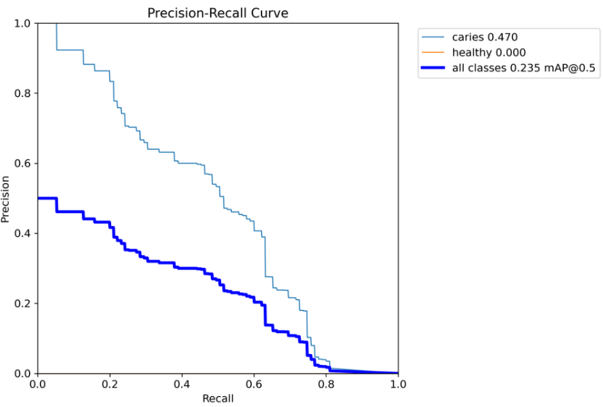Fig.3. Precision-Recall Curve for dataset without augmentation

The model shows a cautious detection pattern with a bias toward precision, especially for caries. However, it struggles with generalizing to the healthy class, likely due to data imbalance and lack of augmentation. Despite limitations, the results validate YOLOv8n’s potential for rapid inference in resource-constrained settings

Data augmentation techniques were then applied to improve the model's ability to generalize across classes, particularly for caries, healthy teeth, and background regions*,* growing the dataset to 340 images. The model showed moderate success in detecting caries (F1 = 0.25, mAP = 0.230), with caries AP at 0.461 but healthy AP at 0.000. Precision peaked at 1.00 with high confidence, while recall remained low (0.34). The confusion matrix showed decent detection of caries but poor performance on healthy teeth, with frequent misclassifications—especially confusing caries with background. Even with augmentation, the model struggled with healthy class sensitivity.Therefore, the data augmentation alone couldn’t solve the underlying class confusion.

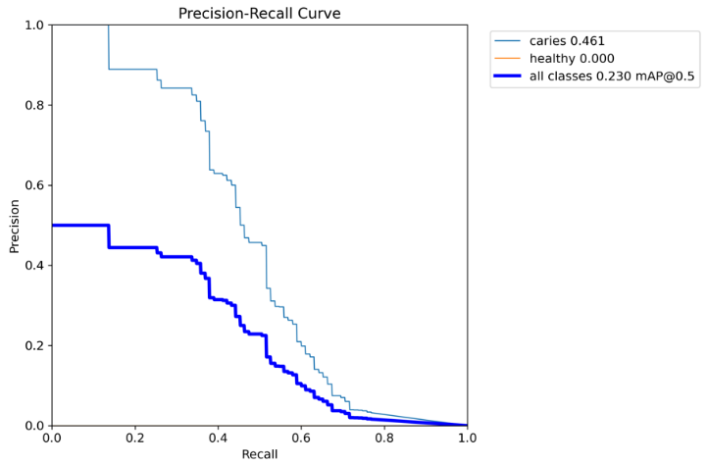

Fig. 4. Precision-Recall Curve for Augmented Dataset

We then trained the model on larger dataset (3000 images, no augmentation) to balance the class, we added a third class (crown). The model detected crowns well, while caries and healthy classes still showed low AP values.This signifies that the model’s tendency to favor well-defined features over subtle or underrepresented ones.

## 

Fig. 5. Precision-Recall Curve for larger Dataset (3000 images)

## The model was then applied to unseen dental images to detect caries and healthy teeth using bounding boxes and confidence scores. The visual results reflect the model's performance across different conditions.

## The YOLOv8 model was evaluated on a test set following training on an augmented dataset of intraoral dental images. The model performed well in detecting carious lesions, especially in clear, well-lit images, with accurate predictions at confidence scores above 0.5. However, it struggled with overlapping boxes in dense cases and produced some low-confidence false positives. Detection of healthy teeth was minimal, reflecting poor generalization to non-caries categories.

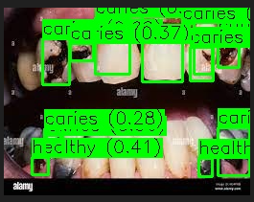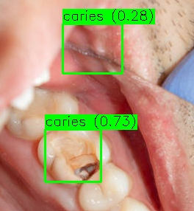

Fig. 6. Result Comparison between Dense and Clear features

## The caries detection model shows strong performance in identifying decayed regions, particularly in high-quality images. Accurate predictions were observed at moderate confidence thresholds (≥0.5), making the model a promising tool for automated dental screening. However, challenges remain, including false positives in complex cases and poor sensitivity to healthy teeth. To improve clinical reliability, further refinement of detection thresholds, improved training data for healthy classes, and post-processing techniques to reduce overlapping boxes are recommended.

***2) YOLOv11 Model:*** The research developed and evaluated a deep learning model for dental image classification by implementing YOLOv11. The study aimed to identify dental caries and healthy areas in anterior and posterior cropped intraoral images. Our team developed a prototype model through training with manually annotated dental images to establish a robust baseline needed for future data augmentation and scaling efforts.

For 100 epochs the YOLOv11 model received training from a manually labeled dental image dataset containing 3,000 samples. Throughout the training epochs a steady reduction of box loss, classification loss, together with distance focal loss (DFL) indicated proper learning of spatial and semantic dental image patterns by the model. The model reached maximum precision of 1.0 within specific confidence ranges which proved its capability to precisely detect cavity and plaque instances under particular thresholds.

Fig.4. F1 Confidence Curve

The mean Average Precision (mAP) at IoU 0.5 reached a value of 0.584 which establishes a strong starting point for training using a dataset of moderate size. The model successfully captured significant caries and plaque patterns throughout its training even though image augmentation was not applied. The F1 score achieved its maximum value of 0.63 at a confidence threshold setting of 0.43 which demonstrated an equilibrium between precision and recall rates.

Fig.5. Raw Confusion Matrix

The normalized confusion matrix showed that correct predictions for cavity and plaque classes reached 60% while the rest were incorrectly labeled as background. The results reveal areas for enhancement yet demonstrate the model's effectiveness in identifying complex dental conditions that challenge human experts as well.

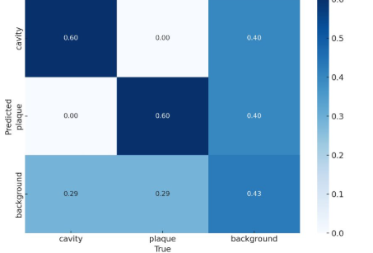

Fig.6. Normalized Confusion Matrix

The precision-recall curve depicted individual class AP scores as 0.609 for anterior cavities and 0.559 for posterior cavities. A full evaluation of the model's performance emerges from the combination of performance metrics together with training logs from results.csv and visual representations shown in confusion_matrix.png, F1_curve.png, and PR_curve.png.

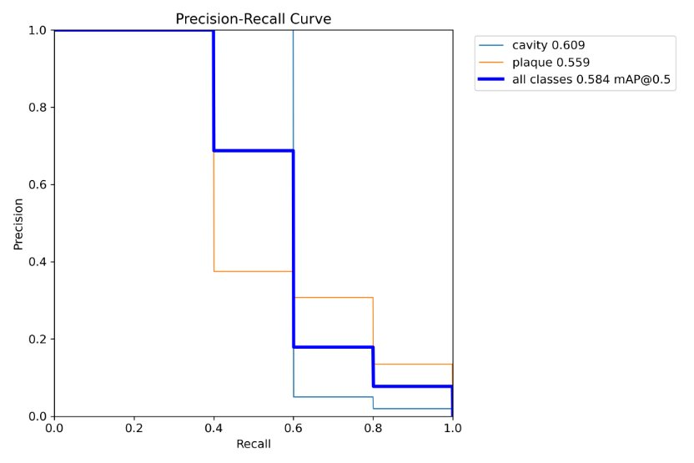

. Fig.6. Precision-Recall Curve

The model's capacity to generalize dental pathology from limited data establishes a robust baseline for subsequent versions. To advance performance future iterations should include data augmentation techniques such as flipping, rotating and cropping as well as adding real-world dental radiographs to the dataset. Enhanced results could be achieved by fine-tuning hyperparameters alongside implementing transfer learning with deeper YOLO models. The results demonstrate that YOLOv11 shows considerable potential for the automation of dental diagnostics across clinical and research environments.

# Discussion

This study investigated the application of two YOLO-based object detection models - YOLOv8 and YOLOv11 - for automated dental condition detection in intraoral images. The primary focus was on detecting caries and healthy teeth, with later expansion to include crowns and plaque in larger datasets. The models were evaluated across datasets of varying sizes and augmentation strategies, offering insights into their respective learning capacities and clinical potential.

**YOLOv8 Model Analysis**

The YOLOv8 Nano model, selected for its lightweight architecture, demonstrated promising speed and inference efficiency on small datasets. However, performance was strongly influenced by dataset size, class imbalance, and image clarity.

Baseline performance (80+ unaugmented images) showed moderate success in identifying caries (AP = 0.470), but failed to detect healthy teeth (AP = 0.000). The low recall (0.39) and high precision at certain thresholds indicate the model made accurate but sparse predictions, likely due to limited training diversity.

Data augmentation (340 images) helped slightly improve caries recognition but had no positive effect on healthy tooth detection. The confusion matrix revealed increasing misclassification - particularly mislabeling background and healthy regions as caries - suggesting that augmentation alone couldn't overcome class confusion.

Larger training dataset (3000 images) with an added crown class significantly improved the model's ability to detect crowns, a more distinct feature. However, caries and healthy detection remained weak, highlighting YOLOv8’s sensitivity to visual distinctiveness and its struggle with subtle or underrepresented features.

Testing on unseen images confirmed that YOLOv8 could detect prominent caries with high confidence, particularly in well-lit images, but suffered in complex scenarios with overlapping or subtle features. The persistent failure to recognize healthy teeth, even with increased data, underscores a critical limitation in class sensitivity and generalization, especially for non-pathological findings.

**YOLOv11 Model Analysis**

YOLOv11, a more advanced and deeper variant, was evaluated on a manually labeled dataset of 3,000 images, targeting anterior and posterior dental conditions. Although augmentation was not applied, the model exhibited superior learning dynamics and detection capability:

Throughout 100 training epochs, loss functions steadily decreased, reflecting effective spatial and semantic pattern learning.

The model achieved a mean Average Precision (mAP@0.5) of 0.584 and a peak F1 score of 0.63 at a 0.43 confidence threshold, outperforming YOLOv8 across nearly all metrics.

Class-wise APs were 0.609 (anterior cavities) and 0.559 (posterior cavities), supporting the model’s robustness in detecting diverse dental pathologies.

The confusion matrix further validated this strength, with 60% correct classifications of cavity and plaque instances and remaining misclassifications largely involving background.

Unlike YOLOv8, YOLOv11's enhanced architecture enabled better pattern abstraction from unaugmented data, suggesting that deeper networks may reduce dependency on pre-processing when data is reasonably annotated. To improve the results, future steps could include increasing the number of healthy examples, applying more diverse augmentations, and using post-processing methods to refine the predictions. This would help reduce errors and improve accuracy in real-world dental screening.

Overall, YOLOv11 shows more promise for detecting dental conditions effectively, but both models need further work to become fully reliable for clinical use.

# Conclusion

This study explored the effectiveness of YOLOv8 and YOLOv11 models in detecting dental caries and healthy teeth using intraoral images. While YOLOv8 performed reasonably well in detecting clear cases of caries, its sensitivity to healthy teeth and complex conditions was limited—mainly due to class imbalance and insufficient variability in the dataset. Even with data augmentation and a larger dataset, the model struggled with false positives and misclassifications, especially for non-caries classes.

In contrast, YOLOv11 showed significantly stronger performance across key metrics, achieving higher average precision and F1 scores without any data augmentation. Its ability to learn spatial and semantic patterns of dental conditions suggests that deeper models are better suited for clinical image classification tasks.

Overall, the results demonstrate the potential of deep learning for dental diagnostics but also highlight the importance of balanced datasets, robust augmentation strategies, and deeper architectures to improve sensitivity and reliability across all dental classes. Future work should focus on expanding data diversity, refining model thresholds, and integrating clinical-grade image inputs to ensure practical application in real-world dental care settings.

##### References

1. Liu, J., Zhang, H., Chen, J., Meng, R., Gao, C., Han, L., Song, Y., Tian, Y., & Wang, Y. (2025). Automated detection and segmentation of dental caries using a novel cascaded learning approach. Biomedical Signal Processing and Control, 102, 107344. https://doi.org/10.1016/j.bspc.2024.107344
2. Salahin, S. M. S., Ullaa, M. D. S., Ahmed, S., Mohammed, N., Farook, T. H., & Dudley, J. (2023). One-Stage Methods of Computer Vision Object Detection to Classify Carious Lesions from Smartphone Imaging. Oral, 3(2), Article 2. https://doi.org/10.3390/oral3020016
3. Tareq, A., Faisal, M. I., Islam, Md. S., Rafa, N. S., Chowdhury, T., Ahmed, S., Farook, T. H., Mohammed, N., & Dudley, J. (2023). Visual Diagnostics of Dental Caries through Deep Learning of Non-Standardised Photographs Using a Hybrid YOLO Ensemble and Transfer Learning Model. International Journal of Environmental ResearchandPublicHealth,20(7),5351. https://doi.org/10.3390/ijerph20075351
4. Ayhan, B., Ayan, E., Karadağ, G., & Bayraktar, Y. (n.d.). Evaluation of Caries Detection on Bitewing Radiographs: A Comparative Analysis of the Improved Deep Learning Model and Dentist Performance. Journal of Esthetic and Restorative Dentistry, n/a(n/a). https://doi.org/10.1111/jerd.13470
5. Yilmaz, S., Tasyurek, M., Amuk, M., Celik, M., & Canger, E. M. (2024). Developing deep learning methods for classification of teeth in dental panoramic radiography. Oral Surgery, Oral Medicine, Oral Pathology and Oral Radiology, 138(1), 118–127. https://doi.org/10.1016/j.oooo.2023.02.021
6. Juyal, A., Tiwari, H., Singh, U. K., Kumar, N., & Kumar, S. (2023). Dental Caries Detection Using Faster R-CNN and YOLO V3. ITM Web of Conferences, 53, 02005.
7. https://doi.org/10.1051/itmconf/20235302005
8. Kadhare, R., Gotmare, Y., Madankar, M., Rathi, H., & Rathi, N. (2024). Deep Learning based Teeth Detection and Numbering System using YOLO. 2024 Asian Conference on Intelligent Technologies (ACOIT), 1–6. https://doi.org/10.1109/ACOIT62457.2024.10939511
9. Ali, M. L., & Zhang, Z. (2024). The YOLO Framework: A Comprehensive Review of Evolution, Applications, and Benchmarks in Object Detection. Computers, 13(12), Article 12. https://doi.org/10.3390/computers13120336
10. Figure1 <https://www.scribbr.com/methodology/stratified-sampling/>
11. Figure2 <https://www.researchgate.net/figure/Example-of-image-annotation-a-Example-of-single-tooth-localization-visualization-blue_fig1_380531104>